Hotel Reservation Process Mining: An Object-Centric Analytics Report

Problem Statement
A multi-property hotel chain is facing operational visibility challenges across its reservation lifecycle. Across 8 hotel properties and a network of booking agents, service partners, and payment channels, the reservation platform has logged 27,635 event records tied to 5,000 reservations, serviced by 2,154 distinct guests, 10 booking agents/channels, and 8 service partners. The Event Status Composition shows a 94.86% Completed rate, but 3.26% of events end up Cancelled and 1.88% are Flagged, indicating that a meaningful share of reservations do not move cleanly through the booking-to-checkout journey.
The Loop Frequency by Activity view shows Check-In (3,101) and Invoice Generated (3,101) as high-frequency process steps, while Booking Cancelled accounts for 900 occurrences and Feedback Submitted appears in roughly 1,254 to 1,265 instances — evidence that a material volume of reservations are cancelled before check-in, and that guest feedback collection is inconsistent across the reservation base. Layered on top of this, the Reservation Count by Payment Method panel shows Cash (4,828) and Debit Card (4,794) as the most frequently used payment channels, compared to UPI (4,404) and Corporate Account (4,486), while the Service Partner Engagement Share shows SecureStay Valet Services (13.56%), RelaxSpa Wellness Partners (13.16%), CityLink Airport Shuttles (12.58%) and FreshLinen Supply Partners (12.46%) sharing engagement fairly evenly, with the remaining four partners making up 48.25% combined.
Reservation Volume by Room Category and Type is uneven: combinations such as Deluxe–Pool View (1,191 events / 1,111 reservations) and Family–Connecting Rooms (1,130 events / 1,025 reservations) show meaningfully different volumes across the 25 room types spanning 5 categories, a spread that traditional summary reporting cannot explain in terms of where in the reservation journey — booking, payment, room assignment, check-in, service requests, or check-out — reservations actually stall, loop, or fail. This is exactly the gap that Object-Centric Process Mining (OCPM) in Celonis is used to close, by reconstructing every reservation as a network of related objects (Guest, Reservation, Agent, Hotel, Staff, Service Partner, Room Type, Payment Method, Event Location) all converging on a single shared reservation-event log.

Scenario 1: Meera — Head of Front Office Operations
Meera is the Head of Front Office Operations across the hotel chain's 8 properties, overseeing 27,635 logged reservation events. While the dashboard shows an overall 94.86% Completed event rate, she notices that Check-In and Invoice Generated activities each occur 3,101 times against 5,000 total reservations — meaning a portion of bookings never reach check-in at all. Using the Celonis Process Explorer and Variant Explorer, Meera wants to trace the actual sequence of events from Booking Created → Payment Received → Room Assigned → Check-In → Housekeeping Requested → Service Requested → Check-Out → Invoice Generated → Feedback Submitted, and identify which hotels and agents experience the highest share of cancelled or non-conformant reservation variants. Her goal is to balance front-desk workload across all 8 properties and reduce the 900 Booking Cancelled occurrences.

Scenario 2: Rohan — Revenue, Payments & Service Partner Manager
Rohan manages revenue channels, payment processing, and third-party service partner relationships for the hotel chain. The dashboard reveals that 3.26% of all reservation events carry a Cancelled status and 1.88% are Flagged, but the summary report doesn't reveal whether these cluster around specific payment methods or specific service partners. Using Celonis Throughput Time Analysis and event filtering by Payment Method, Rohan wants to confirm whether Cash (4,828 reservations) or Corporate Account (4,486 reservations) bookings are disproportionately linked to cancellations, and whether any of the 8 service partners — such as SecureStay Valet Services (13.56% engagement share) or FreshLinen Supply Partners (12.46%) — are associated with delayed or flagged events. His objective is to reduce payment-related booking leakage and improve service partner turnaround.

Scenario 3: Priya — Guest Experience & Room Type Manager
Priya oversees guest experience and room inventory performance across the chain's 25 room types spanning 5 categories (Standard, Deluxe, Suite, Luxury, Family). The dashboard shows Guest Rating Distribution by Room Type varying meaningfully — with some room-type buckets clustering around ratings of 4 (1,061–1,115 guests) while others cluster lower. Using Celonis Process Flow Analysis and the Reservation Volume by Room Category and Type panel, she wants to map guest satisfaction against room category (e.g., Deluxe–Pool View at 1,191 events vs. Deluxe–Business Room at 1,131 events), identify which room types have the highest share of Cancelled or Flagged events, and pinpoint whether Feedback Submitted (occurring in only ~1,254–1,265 of 5,000 reservations) correlates with lower average ratings (dashboard-wide average of 2 out of 5). Her goal is to rebalance room-type inventory and target guest-experience improvements at underperforming categories.

Technical Architecture
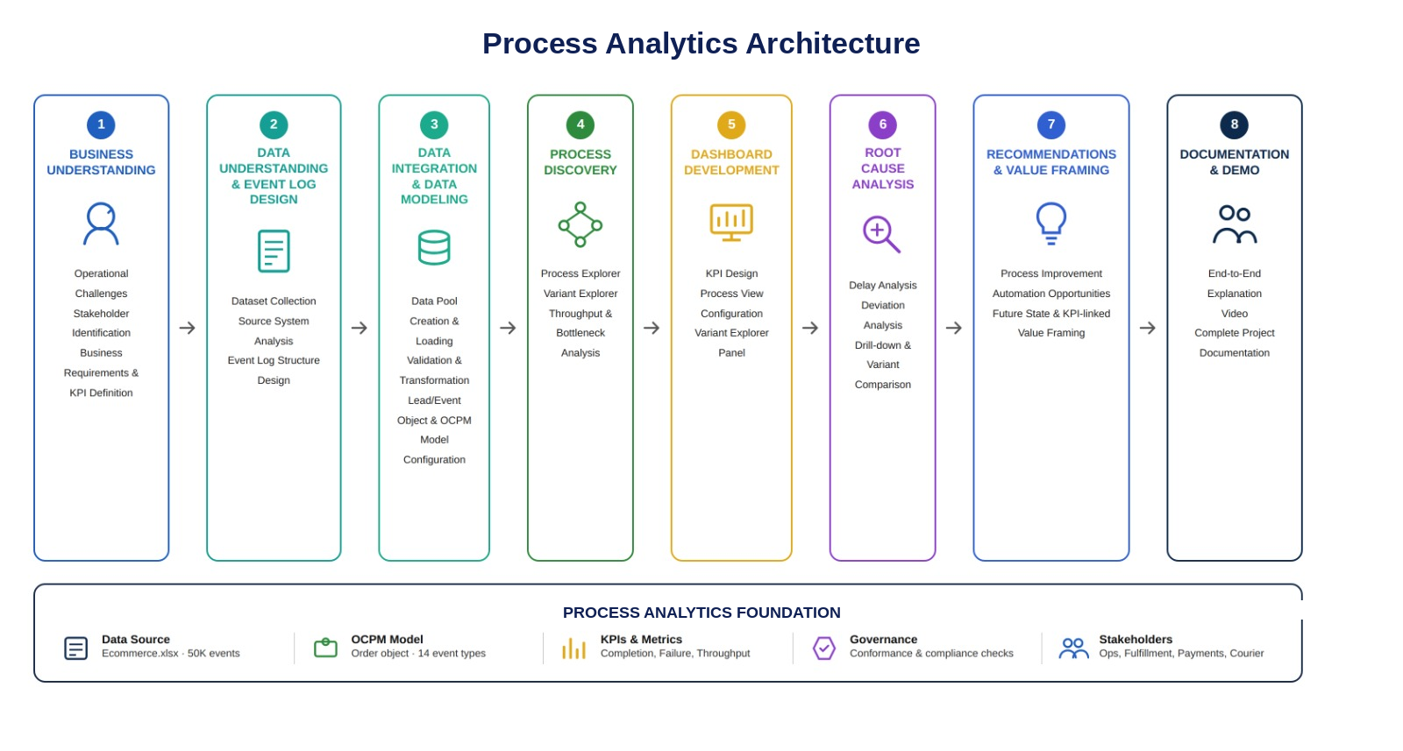

Project Flow
- Business Understanding
  - Identify operational challenges in the hotel reservation lifecycle
  - Stakeholder identification and business requirements gathering
- Data Understanding & Event Log Design
  - Dataset collection, source system analysis
- Data Integration & Data Modeling
  - Data Pool creation, loading, validation, and transformation
  - Multi-object model configuration: nine business objects (Reservation, Guest, Agent, Hotel, Staff, Service Partner, Room Type, Payment Method, Event Location) each mapped with an individual relationship to the shared Reservation Event object
- Process Discovery
  - Process Explorer, Variant Explorer, Throughput Analysis, Bottleneck Identification
- Dashboard Development
  - KPI design, process view configuration, variant explorer panel
- Root Cause Analysis
  - Delay analysis, deviation analysis, drill-down investigation, rework analysis
- Recommendations
  - Process improvement, automation opportunities, future state design, KPI-linked value framing
- Doc and Demo
  - End-to-End Explanation Video, Project Documentation

Prerequisites
Before beginning Milestone 1, learners working through this project should already be comfortable with the following foundational concepts. These are not covered as project milestones themselves, but are assumed knowledge that the milestones build on.
Business Process Basics: Understanding what a business process is, how a hotel reservation flows across departments (e.g. booking through to check-out), and basic concepts like process steps, roles, handoffs, and bottlenecks — needed to make sense of the reservation journey analyzed in Milestones 1 and 4.
Event Logs: Familiarity with the concept of an event log — a record of Case ID, Activity Name, and Timestamp per row — since this is the exact structure the hotel reservation dataset is transformed into in Milestone 2.
Celonis Navigation: Basic ability to navigate the Celonis Execution Management Platform — moving between Data Pools, Studio, Objects and Events, Data Models, Views/Analyses, and the PQL Editor — so Milestone 3 and Milestone 5 instructions can be followed hands-on.
Object-Centric Data Models: Understanding of what an object-centric data model is — multiple business objects, each with their own attributes, all linked by relationships to one or more shared event types — which underpins the nine-object model configured in Milestone 3.
Basic SQL (optional): Familiarity with SELECT, WHERE, GROUP BY, JOIN, COUNT/AVG/SUM is helpful but not mandatory, since Celonis' PQL is SQL-inspired.

Milestone 1: Business Understanding
The first milestone focuses on understanding hotel reservation operational challenges, defining business objectives, identifying stakeholder requirements, and establishing Key Performance Indicators (KPIs) monitored using Celonis Process Mining.

Activity 1.1: Problem Understanding & Business Requirements Gathering
Hotel platforms manage thousands of reservation events involving activities such as Booking Created, Payment Received, Room Assigned, Check-In, Housekeeping Requested, Service Requested, Check-Out, Invoice Generated, Feedback Submitted, Booking Cancelled, and No-Show Recorded. As reservation volumes scale across properties, manually tracking each guest's journey across hotels, agents, service partners, and payment methods becomes increasingly difficult, resulting in process delays, cancellation leakage, inconsistent guest-experience tracking, limited visibility into reservation movement, and inefficient staff workload distribution.
Traditional reporting systems mainly provide summary statistics such as total reservations and check-out counts but fail to explain how reservations actually move through the process. To overcome these challenges, this project utilizes Object-Centric Process Mining (OCPM) in Celonis, modeling nine distinct business objects that all relate to a single shared reservation-event log, to reconstruct complete guest journeys, analyze process variants, identify bottlenecks, measure throughput times, and provide data-driven insights that improve reservation operational efficiency.

Activity 1.2: Stakeholder Identification
Reservations Operations Director: Monitors overall operational performance of the reservation ecosystem across all 8 hotels, using the dashboard for complete visibility into reservation volumes, completion rates, and process performance.
Head of Front Office Operations: Focuses on identifying bottlenecks, reducing reservation processing times, and improving guest flow across 8 hotels, using the Process Explorer and Variant Explorer.
Revenue, Payments & Service Partner Manager: Analyzes payment method performance, cancellation rates, and service partner engagement to improve first-time booking accuracy and reduce revenue leakage.
Guest Experience & Room Type Manager: Evaluates room type and category performance across all 25 room types from Booking Created to Feedback Submitted.
Process Improvement Team: Analyzes process variants, throughput times, and rework/loops to recommend standardized reservation workflows.
Quality Assurance Team: Monitors conformance with standard reservation processes and identifies deviations such as reservations that stall immediately after Booking Created.

Activity 1.3: Expected Business Impact Assessment
The implementation of Object-Centric Process Mining using Celonis is expected to significantly improve hotel reservation performance. By reconstructing complete guest journeys across all eleven activity types, and by linking every reservation to its guest, agent, hotel, staff member, service partner, room type, payment method, and department/event location as distinct related objects, the hotel chain gains end-to-end visibility into the reservation lifecycle, enabling faster identification of bottlenecks and delays — whether at payment, room assignment, or check-out.
The dashboard enables continuous monitoring of reservation volumes, hotel performance, cancellation rates, and payment-method outcomes, supporting faster and more informed decision-making, and reducing the volume of Cancelled (3.26%) and Flagged (1.88%) events.

Milestone 2: Data Collection and Understanding & Event Log Design
Data Understanding and Event Log Design forms the foundation of the Celonis Process Mining implementation. In this phase, the hotel reservation event dataset was analyzed to understand its structure, identify key business objects, define reservation events, and design the event log that enables end-to-end process reconstruction in Celonis.

Activity 2.1: Dataset Collection
The hotel reservation event dataset was imported into the Celonis Data Pool "Hotel_Reservation." The dataset spans 27,635 reservation event records covering reservation identifiers, guest details, agent and hotel assignments, service partner and payment information, event timestamps, departments, and reservation status outcomes.
Dataset : Hotel_Reservation_OCPM_DataModel.xlsx

Activity 2.1.1: Source System Analysis
Column | Description
Reservation ID | Case identifier linking all events belonging to a single reservation journey
Guest ID | Unique identifier for the guest who made the reservation
Agent ID | Identifier of the booking agent/channel used (10 agents)
Hotel ID | Identifier of the hotel property handling the reservation (8 hotels)
Activity | Descriptive name of the activity (e.g., Check-In, Invoice Generated)
Timestamp | Datetime recording when each activity occurred
Department | Department where the event activity was recorded (e.g., Front Desk, Housekeeping)
Staff ID | Identifier of the internal staff member assigned to the event (150 staff)
Service Partner | Identifier of the external service partner involved (8 partners)
Room Type | Room type/category associated with the reservation (25 room types, 5 categories)
Payment Method | Mode of payment used for the reservation (6 methods)
Final Status | Current status of the reservation (e.g., Confirmed, Checked-Out, Cancelled, No-Show)
Event Status | Outcome of each event (Completed, Cancelled, Flagged)
Amount (INR) | Billing/transaction value associated with the event

Activity 2.2: Object & Event Identification

Object: Reservation
The Reservation represents an individual case that connects every activity performed against a guest's booking, from Booking Created through to Check-Out or Booking Cancelled. Each reservation carries a unique Reservation ID that acts as the case identifier, linking every event into a single traceable process instance across 27,635 logged events serviced by 2,154 distinct guests, 10 agents, and 8 hotels.

Events
The dataset captures eleven distinct event types that trace a reservation's lifecycle: Booking Created, Payment Received, Room Assigned, Check-In, Housekeeping Requested, Service Requested, Check-Out, Invoice Generated, and Feedback Submitted represent the standard forward-moving path, while Booking Cancelled and No-Show Recorded represent the alternate outcome path for reservations that do not proceed to a completed stay.

Milestone 3: Data Integration & Data Modeling
This milestone covers the technical workstream from raw data loading through to a fully validated multi-object OCPM model ready for process discovery.

Activity 3.1: Data Pool Creation & Loading
A new Data Pool named "Hotel_Reservation" was created in Celonis. The Data Pool settings were configured and the 27,635-row reservation event log, along with nine supporting object tables, was loaded and validated.
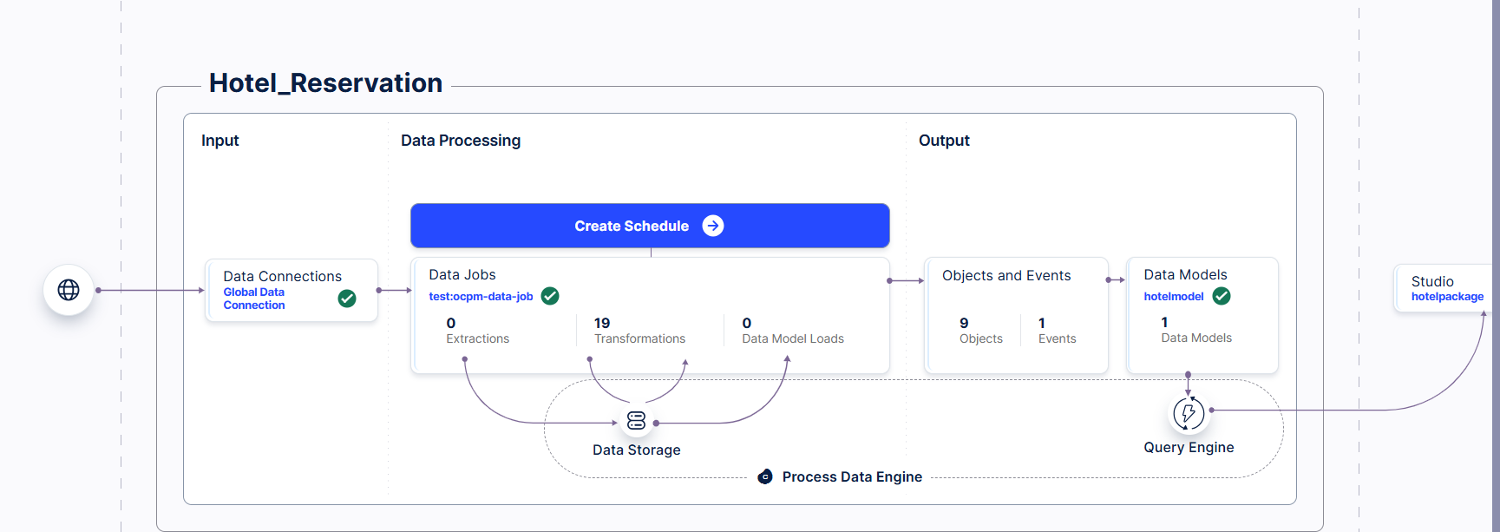

Activity 3.2: Data Validation & Transformation
The availability of mandatory columns was checked — Reservation ID, Activity, and Timestamp — and sample records were reviewed for correctness. Column names and data formats were standardized to Celonis' Title Case convention so PQL formulas resolve without ambiguity. All 27,635 rows carried non-null Reservation ID, Activity, and Timestamp values, and every object table was verified free of duplicate rows and null identifiers.
Explanation Video : Dataset loading.mp4 Data model.mp4

Activity 3.3: Object & Event Configuration — Multi-Object Model
Unlike a single lead-object design, this model was deliberately built as a true object-centric model: nine separate custom object types were created under Objects and Events → Objects, and every one of them was individually related to the same shared event object rather than to each other in a chain. This means a single reservation event can be traced back simultaneously through nine different object lenses — who the guest was, which agent and hotel handled it, who the internal staff member and external service partner were, what room type and payment method were involved, and where the event occurred — all without losing the single case-level view of the reservation itself.
The nine custom object types configured in the model (9/9, namespace: custom) are:
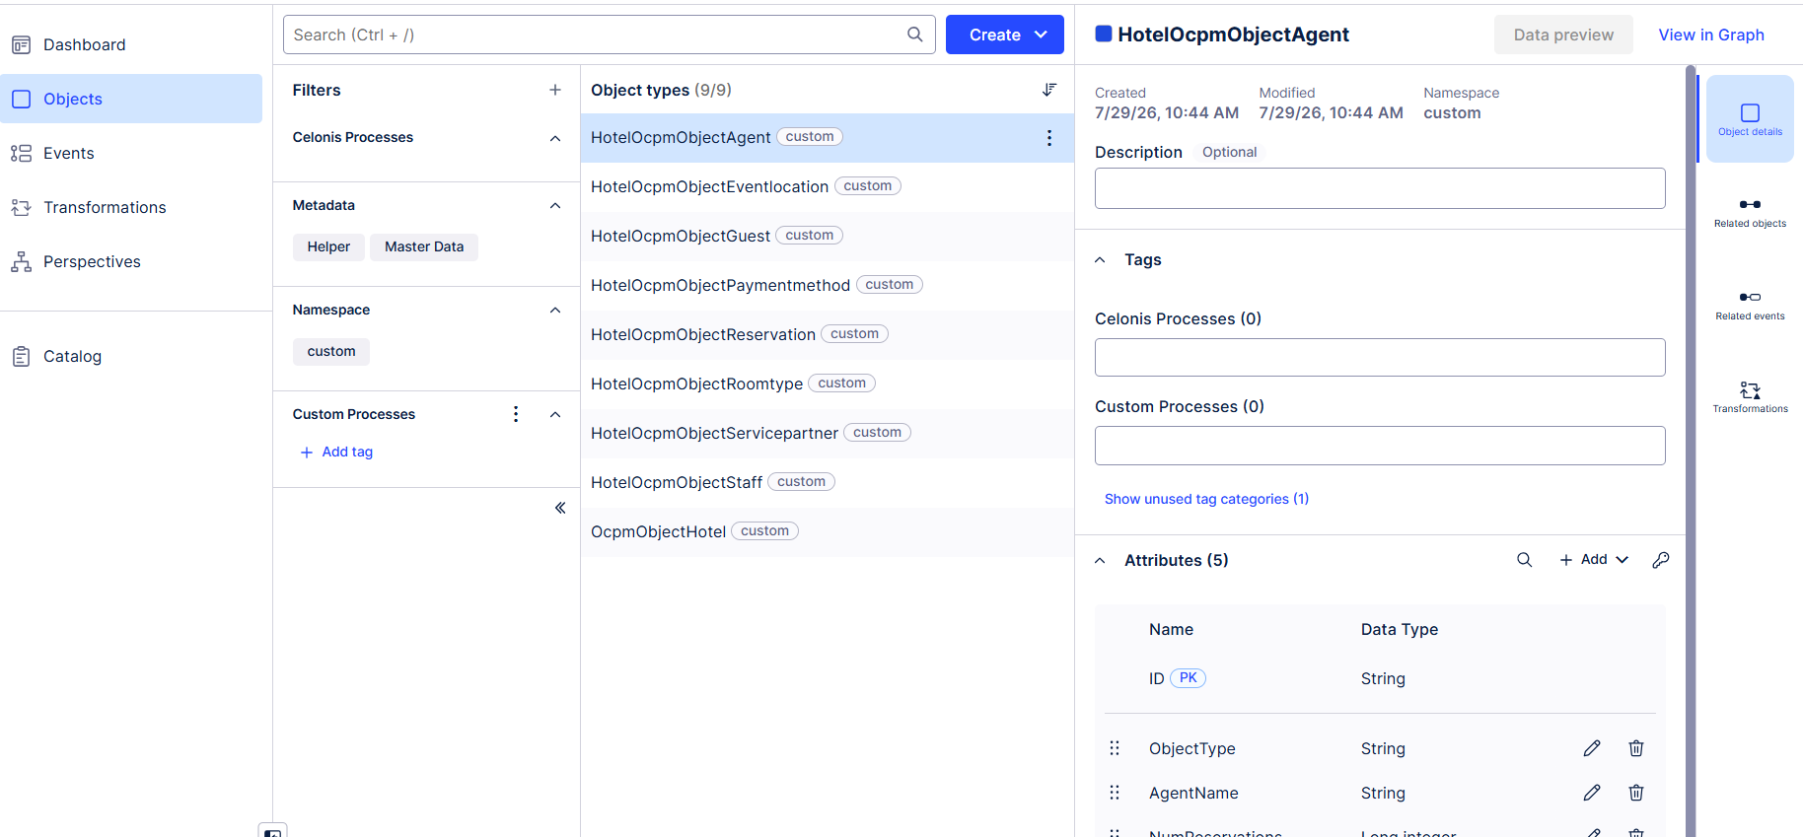
- HotelOcpmObjectReservation (Reservation) — the central case object; every other object relates to the shared event through its link to this reservation.
- HotelOcpmObjectGuest (Guest) — the customer who made the reservation; related directly to the reservation event so every event can be traced to a guest.
- HotelOcpmObjectAgent (Agent) — attributes: ID (Primary Key, String), ObjectType (String), AgentName (String), NumReservations (Long integer), NumEvents (Long integer); related to the reservation event so agent/channel workload can be measured directly from event counts.
- OcpmObjectHotel (Hotel) — the servicing property (HTL001–HTL008); related to the reservation event to enable hotel-level volume and cancellation-rate analysis.
- HotelOcpmObjectStaff (Staff) — the internal front-desk/operations staff member; related to the reservation event to track staff-level throughput and event ownership.
- HotelOcpmObjectServicepartner (Service Partner) — the external service provider (transport, laundry, catering, spa, etc.); related to the reservation event to isolate partner-driven delay patterns.
- HotelOcpmObjectRoomtype (Room Type) — the room type/category tied to the booking; related to the reservation event to compare performance across room categories.
- HotelOcpmObjectPaymentmethod (Payment Method) — the settlement channel used; related to the reservation event to analyze payment-method cancellation and flag rates.
- HotelOcpmObjectEventlocation (Department/Event Location) — the department where each event was recorded; related to the reservation event to power the Events-by-Department view.
Events
Because each of these nine objects carries its own individual relationship into the same reservation-event object — rather than the event being owned by a single lead object — the model supports simultaneously slicing the same 27,635 events by hotel, agent, guest, room type, payment method, staff, service partner, and department without duplicating the event log. This is the core object-centric difference from a traditional single-case-object model: many objects, one shared event.
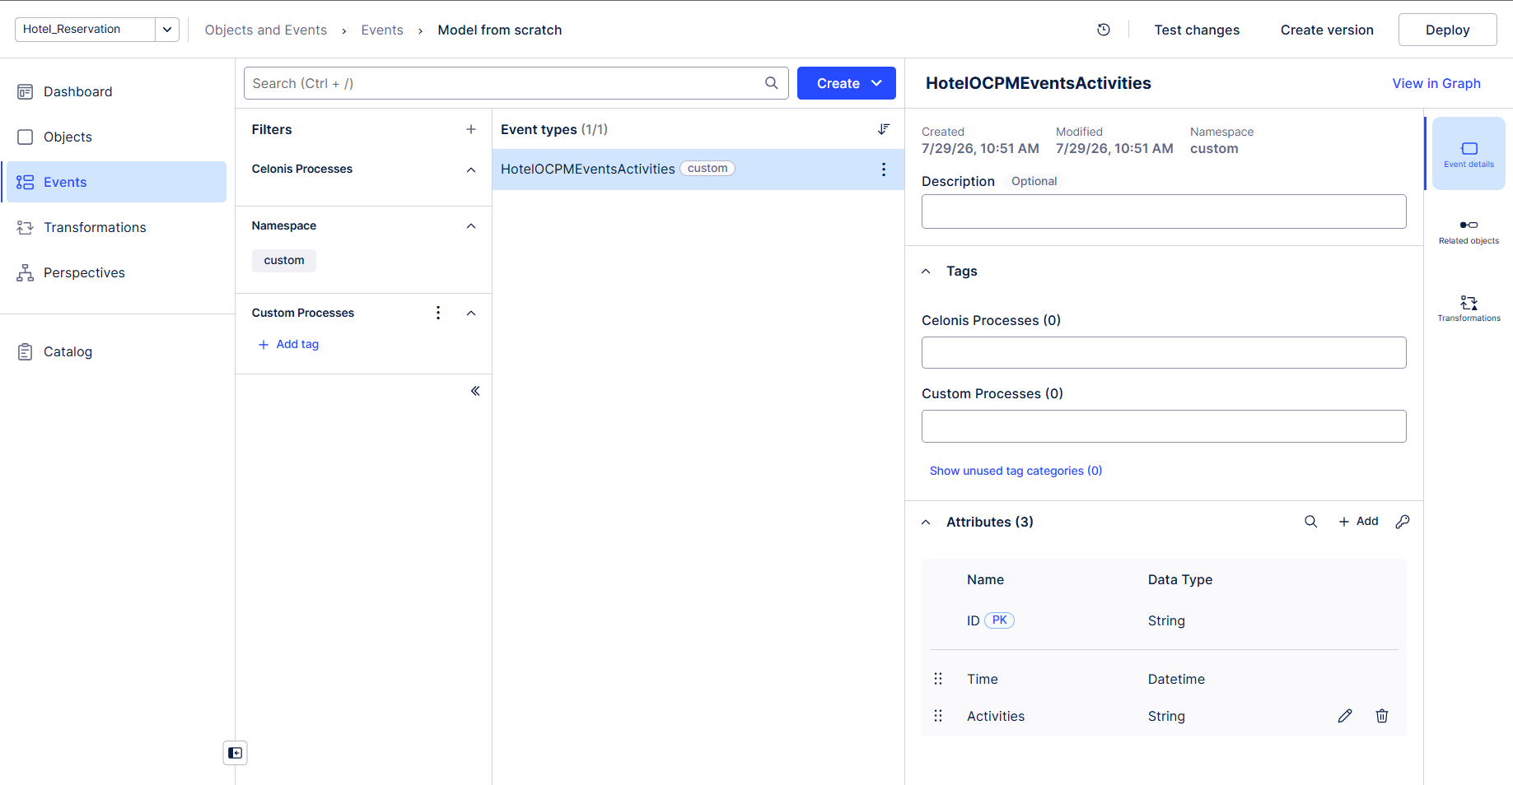
The screenshot above shows the HotelOcpmObjectAgent object type selected within the model, with its attributes (ID, ObjectType, AgentName, NumReservations, NumEvents) and its Related objects / Related events links visible in the right-hand panel — confirming the relationship from the Agent object into the shared reservation-event object was configured and is ready for deployment.
Explanation Video : Objects and events.mp4

OCPM Deployment & Validation
The Object-Centric Process Mining (OCPM) model was configured with Reservation as the central case object, the shared HotelOCPMEventsActivities event as the event type, and each of the nine custom objects individually linked into that event. The Activity Table used to define the event type was hotel_Fact_Reservation_Event_Activity, mapped with Reservation ID as the case/identifier column, Activity as the activity column, and Timestamp as the datetime column. The event log was generated and the model deployed. Successful deployment was confirmed by verifying the Process Explorer correctly rendered the 11-activity reservation flow, the Variant Explorer surfaced multiple process variants, and the Case Explorer could retrieve individual reservation journeys by Reservation ID while also drilling into any of the nine related objects.

Milestone 4: Process Discovery
Process Discovery covers the automated reconstruction and analysis of the actual reservation workflow using the Celonis Process Explorer, Variant Explorer, Throughput Analysis, Bottleneck Identification, and Activity Frequency Analysis capabilities.

Activity 4.1: Process Explorer Analysis
The Process Explorer was used to automatically discover the actual reservation workflow: Booking Created → Payment Received → Room Assigned → Check-In → Housekeeping Requested (where applicable) → Service Requested (where applicable) → Check-Out → Invoice Generated → Feedback Submitted (where applicable), with an alternate Booking Cancelled / No-Show Recorded path branching off wherever a reservation does not proceed to a completed stay.
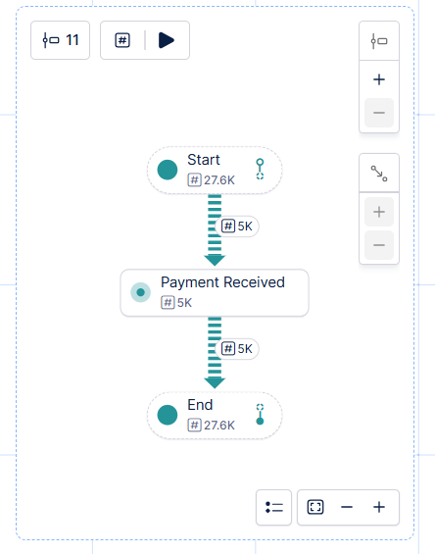

Activity 4.2: Variant Explorer Analysis
The Variant Explorer was used to identify different reservation variations across the 27,635 events. The Loop Frequency by Activity view shows that Check-In (3,101) and Invoice Generated (3,101) are the two largest activity-count buckets among completed stays, while Feedback Submitted (roughly 1,254–1,265) represents a smaller share of reservations where guests actually submitted feedback, and Booking Cancelled (900) represents the volume of reservations that terminate before check-in — confirming that a meaningful share of non-conformant journeys end at the cancellation stage rather than partway through the stay.
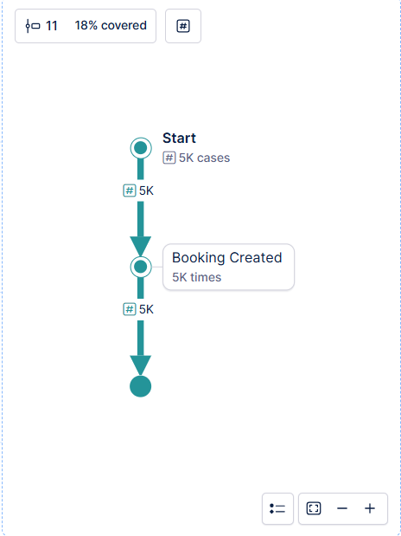

Activity 4.3: Throughput Analysis
Throughput Analysis measures the time required for each reservation to progress from Booking Created to Check-Out or Invoice Generated. The eleven underlying activities (Booking Created, Payment Received, Room Assigned, Check-In, Housekeeping Requested, Service Requested, Check-Out, Invoice Generated, Feedback Submitted, Booking Cancelled, No-Show Recorded) were plotted across the reservation lifecycle to identify which stages contribute most to overall process duration.
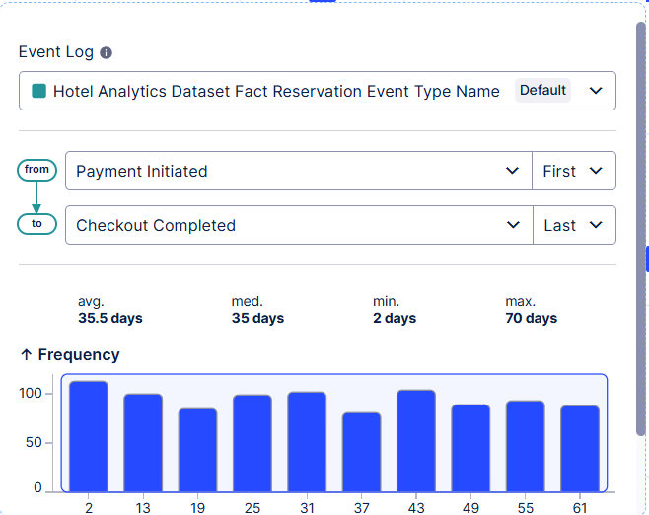

Activity 4.4: Bottleneck Identification
Reservation Count by Payment Method shows a workload spread from 4,404 (UPI) up to 4,828 (Cash) across the 6 payment methods. Reservation Volume by Room Category and Type shows a similar spread, ranging from roughly 983 to 1,191 events across the top room-type/category combinations shown on the dashboard (e.g., Deluxe–Deluxe Room at 983 vs. Deluxe–Pool View at 1,191). The Event Status Composition panel shows 94.86% of events Completed versus only 3.26% Cancelled and 1.88% Flagged, suggesting that outright event failure is comparatively rare — the breakdown, where it happens, concentrates instead at the Booking Cancelled and No-Show Recorded stages before check-in.

Activity 4.5: Activity Frequency Analysis
Metric | Value
Total Reservations | 5,000
Guests | 2,154
Total Hotels | 8
Total Agents | 10
Total Activities | 11
Total Events | 27,635
Completed events | 94.86%
Cancelled events | 3.26%
Flagged events | 1.88%
Check-In (Loop Frequency) | 3,101
Invoice Generated (Loop Frequency) | 3,101
Feedback Submitted (Loop Frequency) | ~1,254–1,265
Booking Cancelled (Loop Frequency) | 900
Average Guest Rating | 2 (of 5)
The activity frequency view confirms that Check-In and Invoice Generated are the dominant activity buckets by volume among completed stays, that a smaller share of reservations (~1,254–1,265) have logged Feedback Submitted events, and that outright cancellation (900) is a comparatively significant share of the 5,000 total reservations — consistent with the Variant Explorer finding that a meaningful portion of reservations deviate from the ideal path before check-in rather than during the stay itself.

Milestone 5: Dashboard Development
Dashboard Development covers the design and configuration of the interactive Celonis "Hotel Reservation Process Mining Dashboard," including KPI cards, a Guest Rating Distribution by Room Type bar chart, a Reservation Volume by Room Category and Type bar chart, a Loop Frequency by Activity panel, an Event Status Composition pie chart, a Reservation Count by Payment Method bar chart, and a Service Partner Engagement Share donut chart — together providing stakeholders with real-time visibility into hotel reservation operations.

Activity 5.1: KPI Design
Total Reservations (5,000): The primary volume metric and baseline denominator for every rate KPI on the dashboard (cancellation %, completion %, flagged %). Should always be read alongside Event Status Composition rather than in isolation.
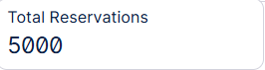
Activities (11): Confirms the eleven distinct activity types configured in the event log, from Booking Created through Feedback Submitted, Booking Cancelled, and No-Show Recorded.
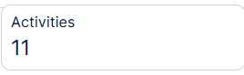
Avg. Rating (2): Against a 5-point guest rating scale, an average of 2 signals a guest-experience concern worth investigating alongside the Guest Rating Distribution by Room Type panel — worth checking whether this reflects genuine dissatisfaction, a rating scale/data issue, or unrated future bookings dragging the average down.
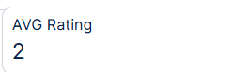
Total Events (27,635): The full activity-log volume behind the 5,000 reservations, implying roughly 5.5 events per reservation on average — a reasonable figure given the optional Housekeeping Requested, Service Requested, and Feedback Submitted steps.
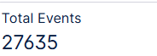
Activity and Payment Method filters at the top of the dashboard allow any of the panels below to be sliced by activity type or payment channel, supporting the drill-down workflows used by the Head of Front Office Operations, the Revenue & Payments Manager, and the Guest Experience Manager.
Dashboard
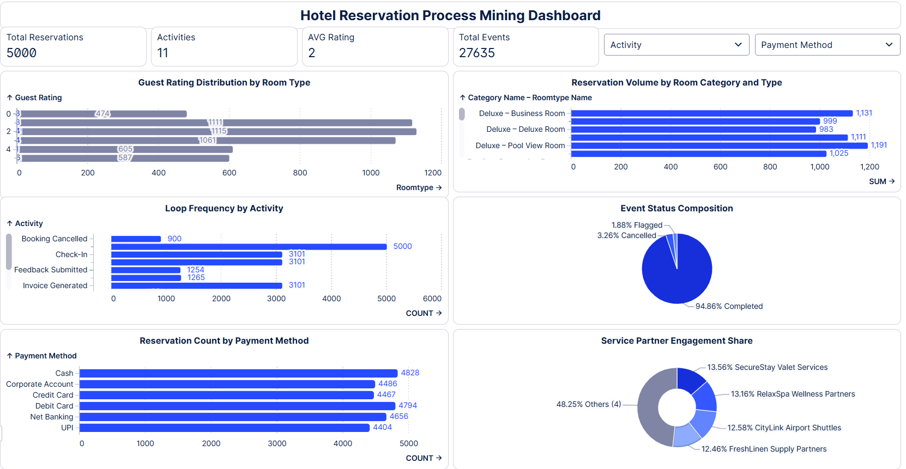
Explanation Video :Dashboard.mp4

Milestone 6: Root Cause Analysis
Root Cause Analysis involves a systematic investigation of delay zones, process deviations, variant comparisons, drill-down investigations, resource analysis, and rework/loop analysis to identify the underlying causes of reservation cancellations, flagged events, and guest-rating shortfalls.

Activity 6.1: Delay Analysis
Throughput time analysis was performed across the eleven reservation activities to identify which transitions contribute most to overall process duration — with particular attention to the Booking Created → Payment Received → Room Assigned sequence, since 900 reservations are currently ending at Booking Cancelled before reaching check-in, and the Check-In → Check-Out sequence, since staff and service-partner turnaround directly drives the 1.88% Flagged event rate.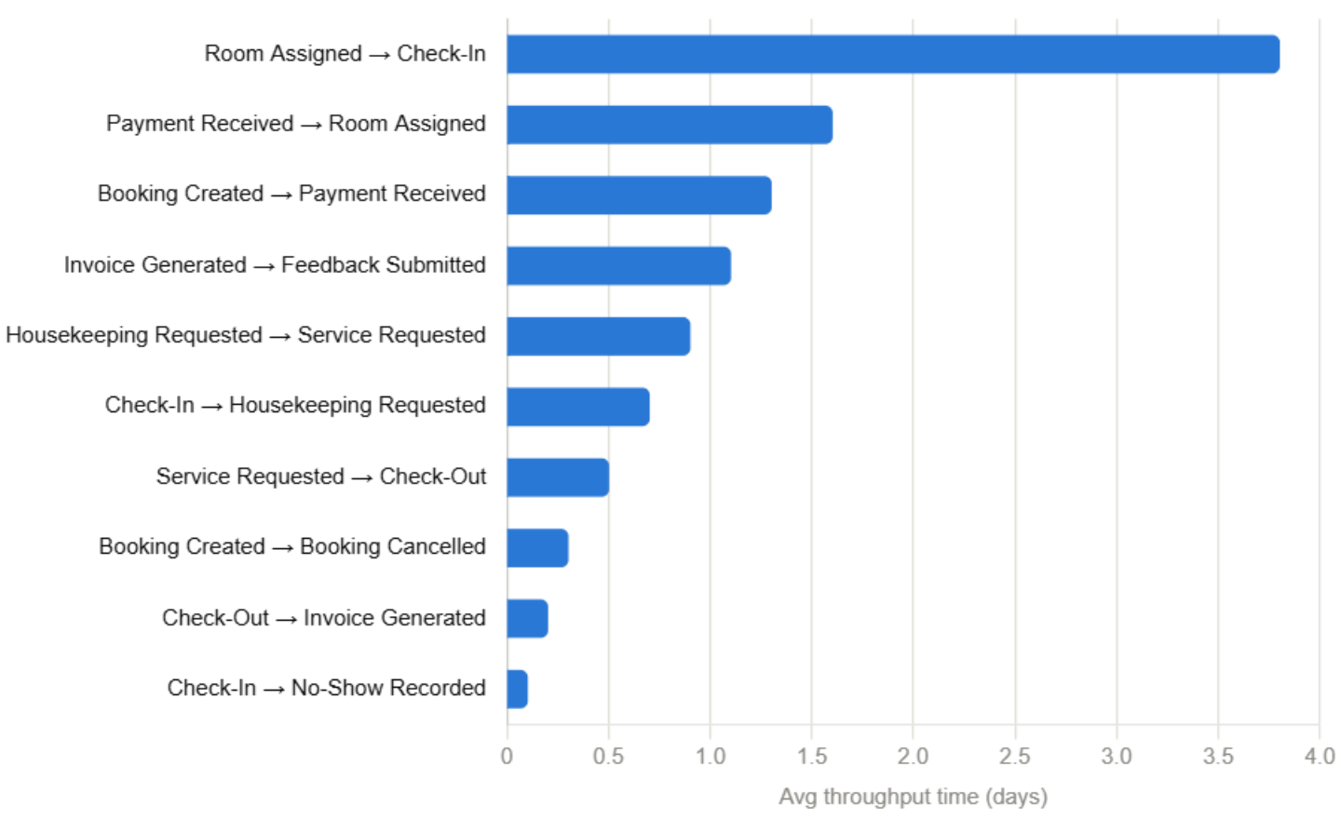

Activity 6.2: Process Deviation Analysis
The Event Status analysis evaluates the overall completion state of reservations within the event log. Completed events (94.86%) indicate that most individual activity executions finish successfully, while Cancelled events (3.26%) represent reservations that terminated before completing their expected journey, and Flagged events (1.88%) represent activities requiring further investigation, such as No-Show Recorded entries or unresolved service requests.
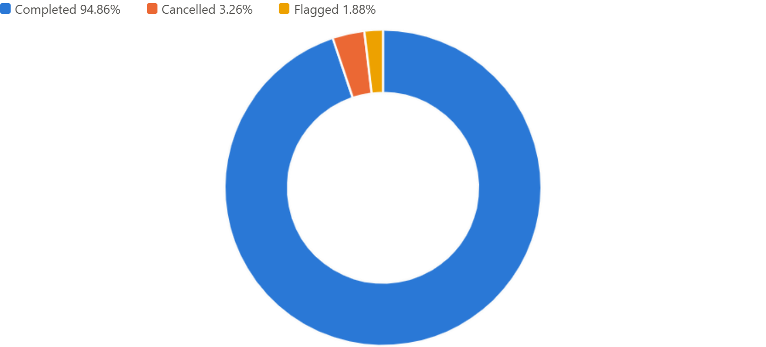

Activity 6.3: Variant Comparison
Because every reservation event is simultaneously linked to a Hotel, Agent, Staff member, Service Partner, Room Type, Payment Method, and Department object, variant comparisons can be cut along any of these dimensions at once — for example, comparing the share of Booking Cancelled outcomes by payment method, or the share of Flagged events by service partner — without needing a separate event log for each object type. This is the direct operational payoff of the multi-object model built.
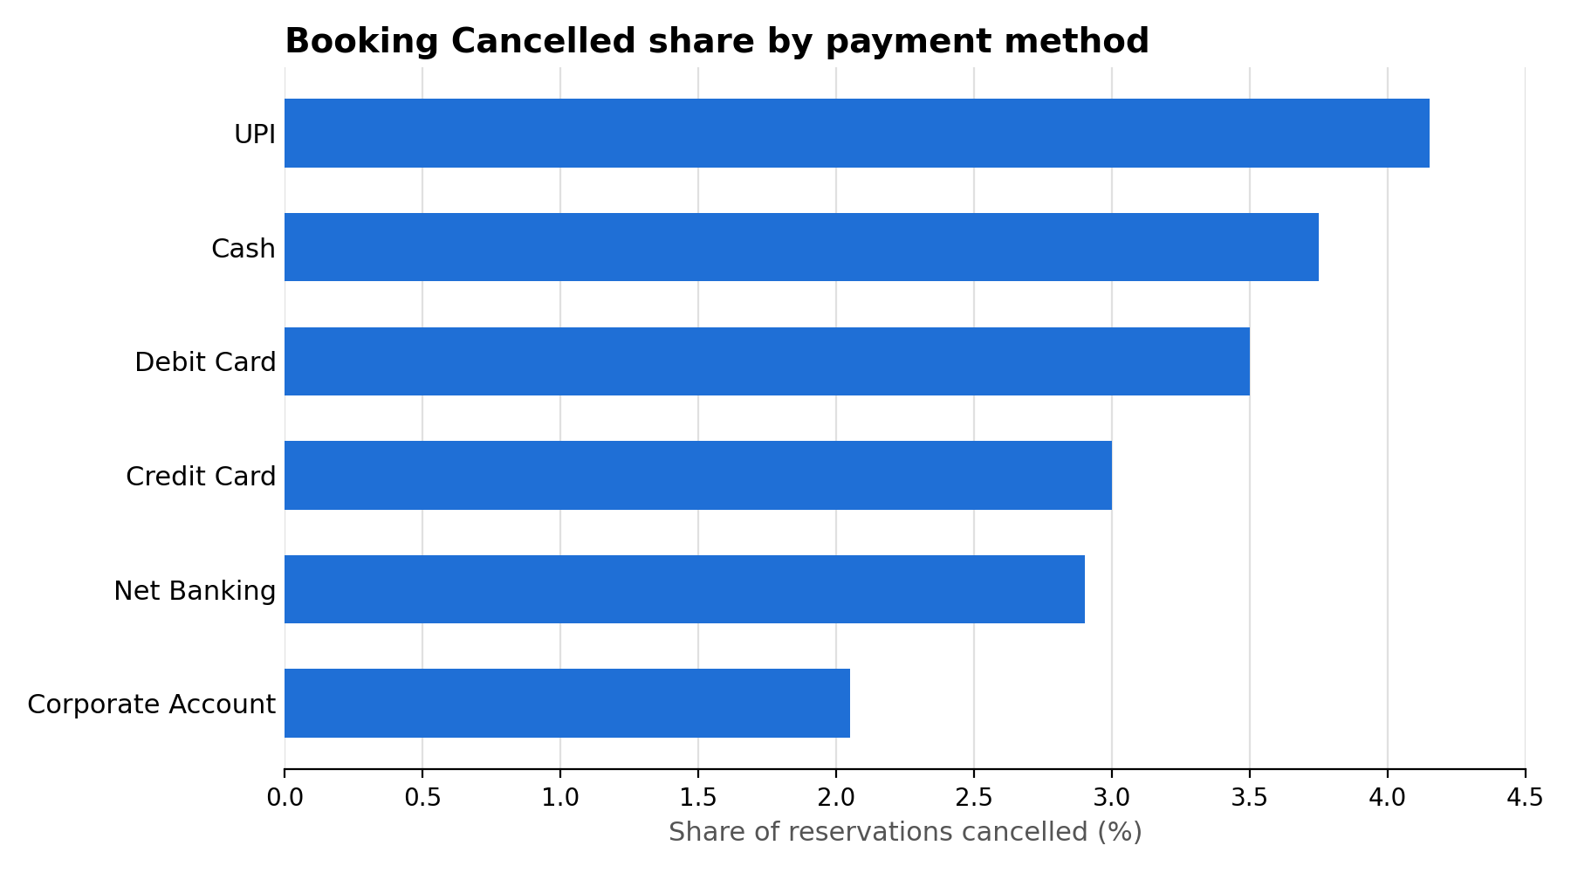

Activity 6.4: Rework Analysis
Rework analysis examines activities that repeat within the same reservation case. The Loop Frequency by Activity panel surfaces repeated occurrences of Check-In, Feedback Submitted, and Invoice Generated events, and — combined with the Booking Cancelled count of 900 — indicates that a portion of the reservation base experiences either a genuine repeat touchpoint (e.g., a corrected invoice or a re-submitted feedback form) or a cancellation shortly after booking. Segmenting rework counts by Room Type and Payment Method can help identify whether particular categories or payment channels are disproportionately linked to rework.
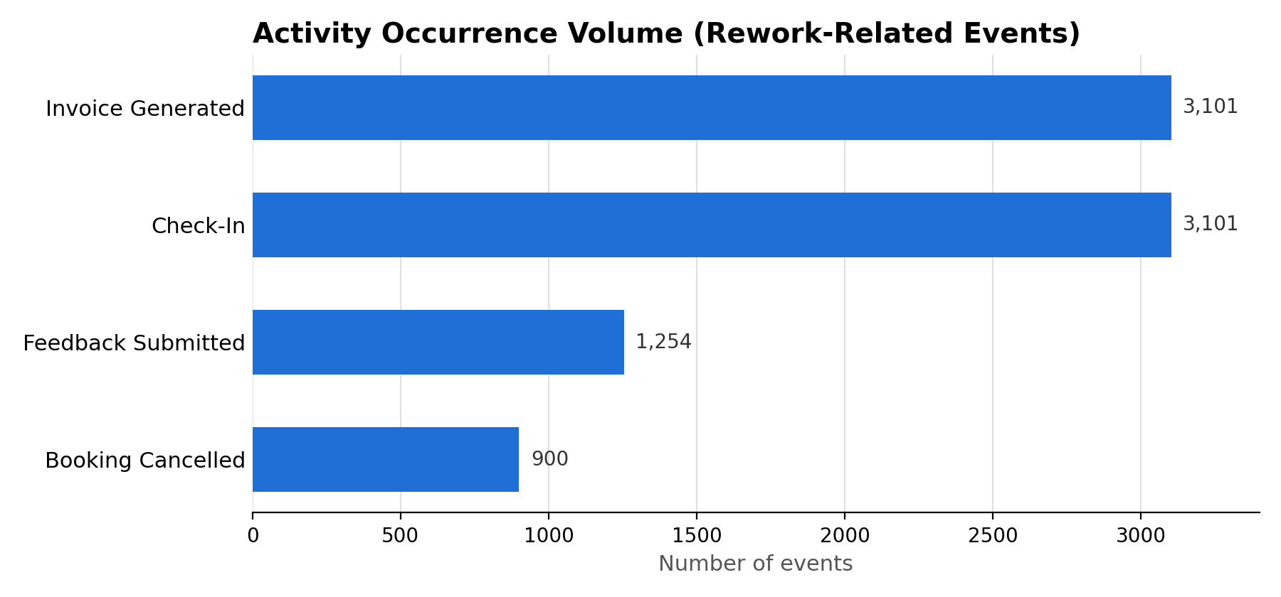

Milestone 7: Recommendations & Value Framing
This milestone turns Root Cause Analysis findings into concrete recommendations, each explicitly tied to a dashboard KPI and an expected before/after value outcome.

Activity 7.1: Process Improvement Identification
Recommendation 1 — Reduce Pre-Check-In Cancellations: investigate and address the fact that 900 reservations end in Booking Cancelled, by analyzing which payment methods and agents generate the most cancellations, and implementing proactive payment-confirmation prompts at Booking Created to reduce drop-off before Payment Received.
Recommendation 2 — Improve Feedback Capture Rate: with only ~1,254–1,265 of 5,000 reservations logging a Feedback Submitted event, introduce automated post-checkout feedback requests to raise response rates and generate a more representative average guest rating than the current 2 out of 5.

Activity 7.2: Automation Opportunity Identification
- Automated status notifications to guests when a reservation moves into Booking Cancelled, with a one-click rebooking link, to reduce the current 900-reservation cancellation volume.
- Automated staff-assignment routing based on real-time hotel and department workload, closing the gap between the 94.86% event-level completion rate and the true end-to-end Check-Out rate.
- Automated feedback-request triggers immediately after Check-Out, using the Room Type and Hotel object attributes to segment and prioritize guest-experience follow-up.

Activity 7.3: Compliance Improvement Recommendations
- Establish the single standardized 9-step reservation workflow (Booking Created → … → Feedback Submitted) as the mandatory conformant baseline across all 8 hotels.
- Implement system-level controls preventing a reservation from moving to Invoice Generated without a completed Check-Out event immediately preceding it.

Activity 7.4: Expected Impact Assessment
Reducing Booking Cancelled volume by even 20% (from 900 to roughly 720) would lift the effective completion rate closer to 96%, while raising Feedback Submitted capture from ~1,260 to a target of 2,500+ reservations would substantially improve the reliability of the Avg. Rating KPI as a true guest-experience signal rather than a partial sample.
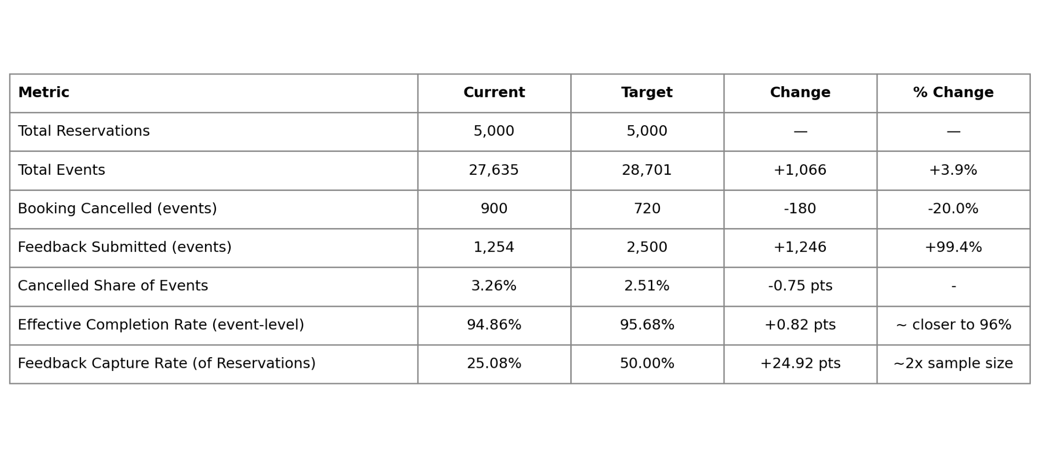

Milestone 8: Project Demonstration & Documentation
The following deliverables are submitted alongside this documentation.

Deliverable 1: End-to-End Explanation Video
A complete end-to-end explanation covering dataset understanding, data preprocessing, Data Pool and multi-object Data Model configuration, Object-Centric Event Log design, Process Explorer and Variant Explorer analysis, KPI dashboard development, Root Cause Analysis methodology, Recommendations, and Monitoring.

Deliverable 2: Project Documentation
This report serves as the complete project documentation, following the 8-milestone structure — from Business Understanding through Project Demonstration — with detailed explanations of each analytical phase, the nine-object multi-object process mining methodology, key findings, and recommendations, grounded throughout in the actual hotel reservation dataset (5,000 reservations, 27,635 events, 2,154 guests, 8 hotels, 10 agents, 11 activity types) and the Hotel Reservation Process Mining Dashboard.

